**Project Design Phase-II**

**Data Flow Diagram & User Stories**

|  |  |
| --- | --- |
| Date | 18-08-2025 |
| Team ID |  |
| Project Name | shopEZ |
| Maximum Marks | 4 Marks |

**Data Flow Diagrams:**

A **Data Flow Diagram (DFD)** illustrates how data moves within the shopEZ platform. It captures how users interact with the system, how information flows between different components, and where the data is stored.

Example: DFD Level 0 (Industry Standard)

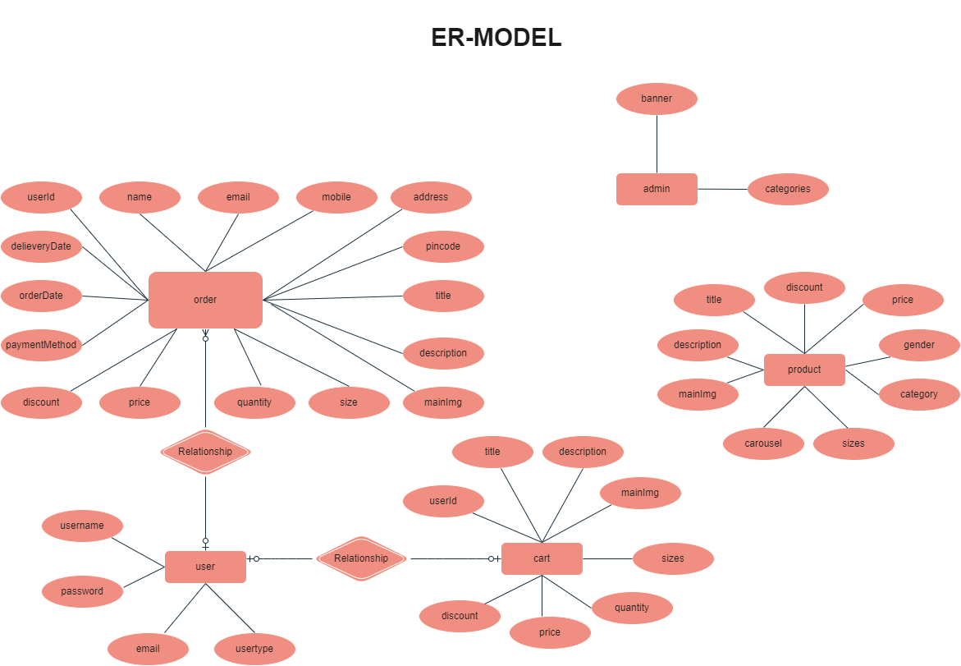

**User Stories**

• The Database section represents the database that stores collections for Users, Admin, Cart, Orders and products.

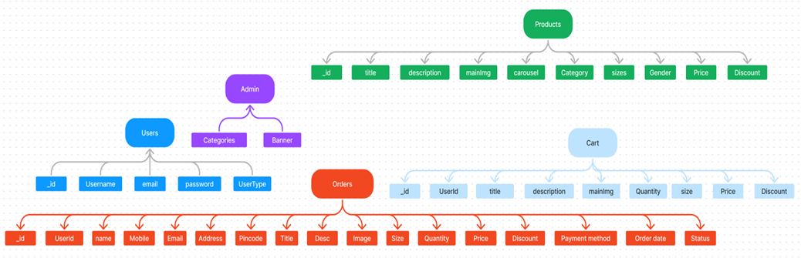

The ShopEZ ER-diagram represents the entities and relationships involved in an e-commerce system.  It illustrates how users, products, cart, and orders are interconnected. Here is a breakdown of the entities  and their relationships:

**USER:** Represents the individuals or entities who are registered in the platform.

**Admin:** Represents a collection with important details such as Banner image and Categories.

**Products:** Represents a collection of all the products available in the platform.

**Cart:** This collection stores all the products that are added to the cart by users. Here, the elements in the cart are  differentiated by the user Id.

**Orders:** This collection stores all the orders that are made by the users in the platform.

**Features:**

1. **Comprehensive Product Catalog:** ShopEZ boasts an extensive catalog of products, offering  a diverse range of items and options for shoppers. You can effortlessly explore and discover  various products, complete with detailed descriptions, customer reviews, pricing, and available  discounts, to find the perfect items for your needs.

**2. Shop Now Button:** Each product listing features a convenient "Shop Now" button. When you  find a product that aligns with your preferences, simply click on the button to initiate the  purchasing process.

3. **Order Details Page**: Upon clicking the "Shop Now" button, you will be directed to an order  details page. Here, you can provide relevant information such as your shipping address,  preferred payment method, and any specific product requirements.

4. **Secure and Efficient Checkout Process:** ShopEZ guarantees a secure and efficient checkout  process. Your personal information will be handled with the utmost security, and we strive to  make the purchasing process as swift and trouble-free as possible.

5. **Order Confirmation and Details:** After successfully placing an order, you will receive a  confirmation notification. Subsequently, you will be directed to an order details page, where  you can review all pertinent information about your order, including shipping details, payment  method, and any specific product requests you specified.

In addition to these user-centric features, ShopEZ provides a robust seller dashboard, offering  sellers an array of functionalities to efficiently manage their products and sales. With the seller  dashboard, sellers can add and oversee multiple product listings, view order history, monitor  customer activity, and access order details for all purchases.

ShopEZ is designed to elevate your online shopping experience by providing a seamless and  user-friendly way to discover and purchase products. With our efficient checkout process,  comprehensive product catalog, and robust seller dashboard, we ensure a convenient and  enjoyable online shopping experience for both shoppers and sellers alike.